LAB-2: Use Case Diagram for SecureShare
NAME: DEVANSH SHARMA
UNIV ROLL NO : 202401100200128
BRANCH: CSE B

Overview
SecureShare has five human actors and 22 use cases, derived from the user classes in SRS Section 2.3, the functional requirements FR-001 to FR-034 in Section 3, and the scenarios UC-01 to UC-04 in Section 7. This lab gives the actors and their roles, the use case diagram, and the function, precondition and postcondition of every use case.

Actors and their roles
Five primary actors start use cases; four external systems support them and are not drawn in the diagram.
Actor | Type | Role in SecureShare
End User (File Owner) | Primary | Registered individual who registers, logs in, uploads and encrypts files, organizes and searches them, shares files with users or by link, revokes access, manages versions, deletes and restores files, and receives notifications.
File Recipient / Guest | Primary | External party who opens a shared link, with or without a full account, and views or downloads the file within the permission granted.
Workspace Administrator | Primary | Manages users, groups, storage quotas and sharing policy for an organization; can revoke any share, end a user's sessions, and review audit logs.
Security / Compliance Auditor | Primary | Reviews audit logs and access reports with read-only access, and exports logs for compliance reporting.
System Administrator | Primary | Manages infrastructure, encryption keys, backups and platform configuration.
Key Management Service (KMS) | Supporting system | Generates, rotates and releases encryption keys when files are encrypted or decrypted.
Antivirus / Malware Scanner | Supporting system | Scans each uploaded file before it becomes available and flags files to quarantine.
Email / SMS Provider | Supporting system | Delivers verification links, MFA one-time codes, share invitations and security notifications.
Identity Provider (SSO) | Supporting system | Authenticates users of an organization through SAML 2.0 or OAuth 2.0.

Use case diagram
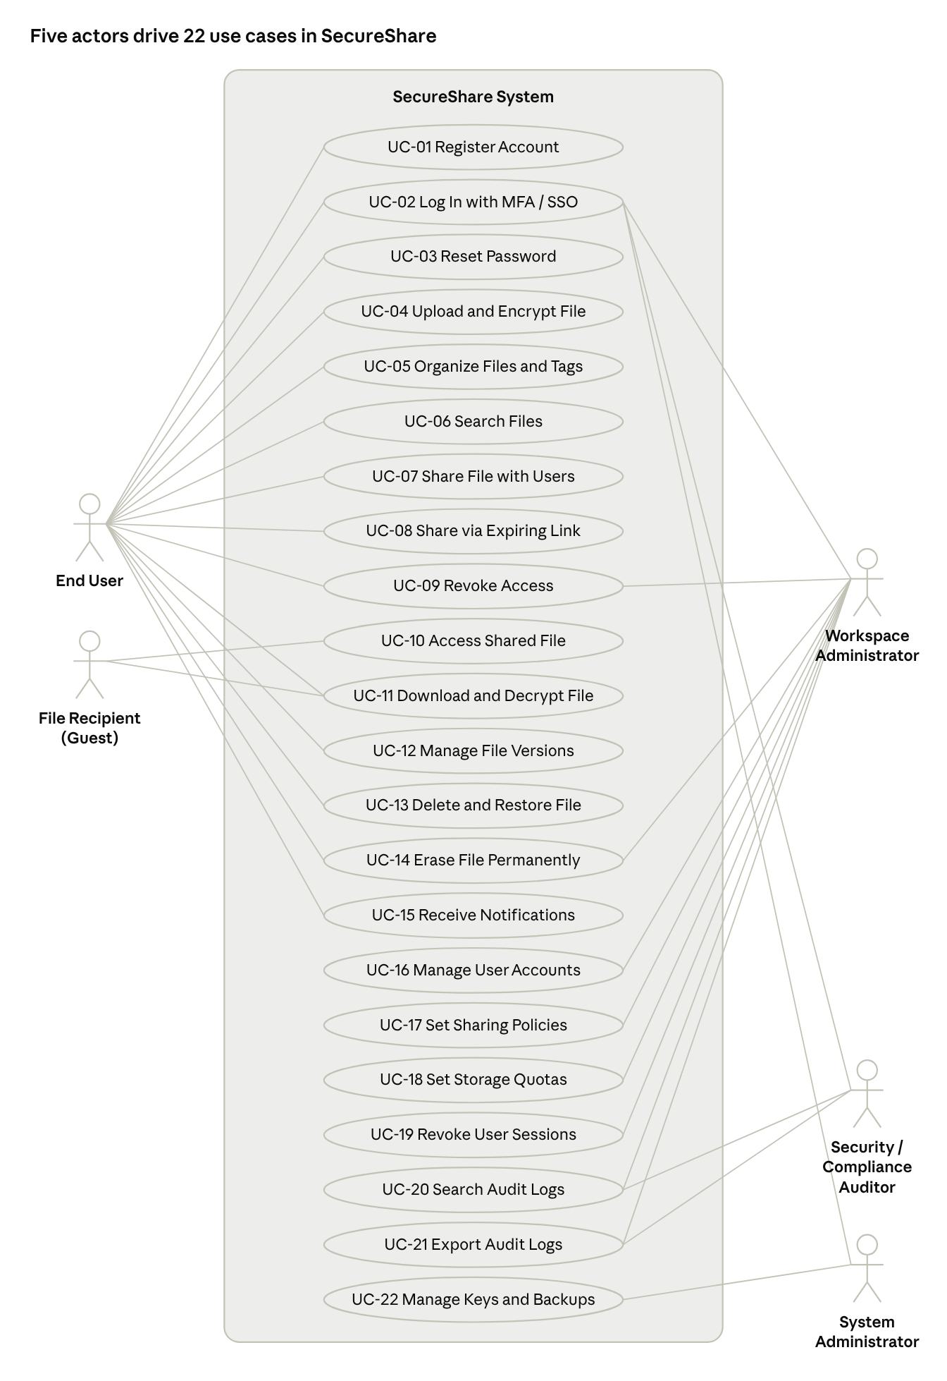
use case diagram · 5 actors, 22 use cases
The End User reaches the most use cases, Log In is shared by the four signed-in actors, and Revoke Access, Erase File Permanently and the audit-log use cases are shared between users and administrators.

Use case specifications
Each row gives the function, precondition and postcondition of one use case; the last column lists the SRS requirements it covers.
ID | Use case | Actor | Function | Precondition | Postcondition | SRS
UC-01 | Register Account | End User | Creates a new account with an email address and a password that meets the complexity policy, then verifies the email through a time-limited link. | The user has a valid email address and no existing account. | The account exists and is activated after email confirmation. | FR-001, FR-002
UC-02 | Log In with MFA / SSO | End User, Workspace Administrator, Auditor, System Administrator | Authenticates a user by password or organizational SSO, then verifies a TOTP or SMS one-time code; locks the account for 15 minutes after five failed attempts. | The user has an activated account. | The user has an active session with the rights of their role; a lockout is applied and notified after repeated failures. | FR-003, FR-004, FR-005
UC-03 | Reset Password | End User | Lets a user who forgot a password set a new one through a verified, time-limited reset link. | The user has an activated account and access to the registered email. | The password is changed and the reset link can no longer be used. | FR-006
UC-04 | Upload and Encrypt File | End User | Uploads one or more files up to the size limit, encrypts them client-side where supported and with AES-256 at rest, scans them for malware, and records the metadata. | The user is logged in and has storage quota left. | The file is stored encrypted, scanned, and visible in the user's file list; an infected file is quarantined instead. | FR-007 to FR-011
UC-05 | Organize Files and Tags | End User | Creates nested folders, moves files between them, and applies tags or labels. | The user is logged in and owns or manages the items. | Folders, locations and tags are updated and shown in the file browser. | FR-012, FR-029
UC-06 | Search Files | End User | Finds files by name, tag, owner or file type. | The user is logged in. | A list of matching files the user is allowed to see is displayed. | FR-028
UC-07 | Share File with Users | End User (File Owner) | Shares a file or folder with registered users at a chosen permission level: view, download, edit or manage. | The user owns the item or has manage-level access, and the recipients are registered. | A permission record exists for each recipient, is limited to the granted level, and is written to the audit log. | FR-013, FR-016
UC-08 | Share via Expiring Link | End User (File Owner) | Generates a signed link with an expiry date, optional password, optional download limit, and optional restriction to a domain or verified identity. | The user owns the file or has manage-level access. | A time-bound, auditable access link exists and is recorded in the audit log. | FR-014, FR-017
UC-09 | Revoke Access | End User, Workspace Administrator | Immediately invalidates a direct share or a shared link. | An active share or link exists for the resource. | The previously authorized party can no longer access the resource, and the revocation is logged. | FR-015
UC-10 | Access Shared File | File Recipient / Guest | Opens a shared link, enters the password if required, and the system checks the token, expiry and permission before releasing access. | The guest holds a valid, unexpired, unrevoked link. | Access is granted within the permission level, or refused; the event is logged and the owner may be notified. | FR-016, FR-018
UC-11 | Download and Decrypt File | End User, File Recipient / Guest | Retrieves the encrypted file through a time-limited URL, decrypts it in the browser, and checks its checksum. | The user has at least download permission on the file and it passed the malware scan. | The user holds a verified, decrypted copy of the file and the download is written to the audit log. | FR-019, FR-020, FR-021
UC-12 | Manage File Versions | End User | Keeps earlier versions when a file is replaced, and lets an authorized user view, download or restore any of them. | The file exists and the user has edit or manage permission. | The chosen version is available or restored as current, and older versions remain retained. | FR-022
UC-13 | Delete and Restore File | End User | Moves a file to a recoverable trash for the retention period (30 days by default) and restores it on request. | The user owns the file or has manage permission. | The file is in the trash, or back in its folder after a restore; after the period it is permanently deleted. | FR-023
UC-14 | Erase File Permanently | End User, Workspace Administrator | Irreversibly erases the file content and its encryption keys after a verified deletion request. | A verified erasure request exists for the file. | The file and its key material cannot be recovered, and the erasure is logged. | FR-024
UC-15 | Receive Notifications | End User | Sends email notices for security events, share invitations, expiring links, and access or download of shared files. | The user has a verified email and has set notification preferences. | The notification is delivered to the user. | FR-018, FR-030
UC-16 | Manage User Accounts | Workspace Administrator | Creates, suspends and deactivates user accounts in the organization, and can reassign a departing user's files. | The administrator is logged in with organization-management privileges. | The account status is updated; a deactivated user can no longer log in and ownership of their files is resolved per policy. | FR-031
UC-17 | Set Sharing Policies | Workspace Administrator | Defines organization-wide rules such as disallowing public links, enforcing MFA, and restricting external domains. | The administrator is logged in with policy privileges. | The policy is saved and applies to all later sharing and logins in the organization. | FR-033
UC-18 | Set Storage Quotas | Workspace Administrator | Assigns a storage limit to each user or group. | The administrator is logged in and the user or group exists. | The quota is stored, and uploads beyond it are refused. | FR-032
UC-19 | Revoke User Sessions | Workspace Administrator | Ends all active sessions of a chosen user, for example on offboarding. | The administrator is logged in and the user has active sessions. | All sessions and access tokens of the user are invalid, and the user must log in again. | FR-034
UC-20 | Search Audit Logs | Auditor, Workspace Administrator | Searches and filters the audit trail by user, file, date range and action type. | The actor is logged in with audit-log access. | The matching entries are displayed; the log itself is not changed. | FR-025, FR-026
UC-21 | Export Audit Logs | Auditor, Workspace Administrator | Exports the selected audit entries as a CSV file for external compliance reporting. | The actor is logged in with audit-log access and has selected a filter or period. | A CSV file with the selected entries is delivered, and the log remains unchanged. | FR-027
UC-22 | Manage Keys and Backups | System Administrator | Oversees encryption-key rotation through the KMS, backups, and platform configuration. | The administrator is logged in with infrastructure privileges and the KMS is reachable. | Keys, backups and settings are updated, with keys kept apart from the encrypted data. | NFR-002, Sections 2.3 and 5.4

Include and extend relationships
Base use cases reuse shared steps through include, and optional behavior is added through extend.
Base use case | Relationship | Related behavior
UC-02 Log In with MFA / SSO | include | Verify one-time code (MFA), required by FR-004
UC-02 Log In with MFA / SSO | extend | Sign in through organizational SSO, only where an administrator has configured it (FR-003)
UC-04 Upload and Encrypt File | include | Encrypt file with a key from the KMS, and scan file for malware
UC-07, UC-08, UC-09, UC-13, UC-14 | include | Record audit log entry, required by FR-025
UC-08 Share via Expiring Link | extend | Protect link with a password, or restrict it to a domain (FR-014, FR-017)
UC-10 Access Shared File | include | Validate link token and permission
UC-11 Download and Decrypt File | include | Verify checksum, and release the decryption key
UC-13 Delete and Restore File | extend | Erase file permanently, after the retention period or on a verified request (UC-14)

